Lab 3: Coastal Evolution Across Scales

General Instructions & Background

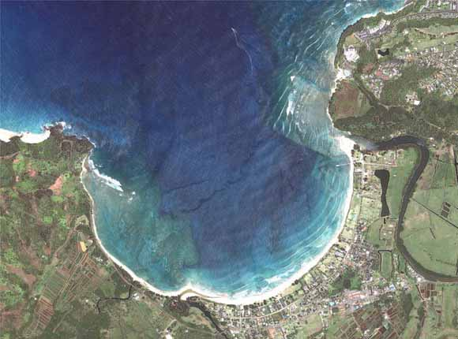

Figure 1 QuickBird satellite image of Hanalei Bay, Kaua‘I (P. Chavez, USGS)

The goals of this lab are:

* build upon the previous lab where we explore beach evolution in 1D and for a single storm event by looking at larger spatial and/or temporal scales.
* you will look at the evolution of coastal system in 2D and explore the complex interactions between hydrodynamics and morphodynamics using two types of models (**COVE** & **XBeach**).
* to investigate the impact of wave climate on crenulated bay shorelines evolution.
* to estimate the effect of shallow reef on the morphodynamics of beach during storm conditions.

Through the notes and the notebooks you will see questions. You will need to provide solution for each of them.

Here we will mostly use the same **IPython notebook** for the entire lab and we will run different models with changing input conditions. For some of the visualization we will be using **Paraview**.

Again if at any point you don’t understand something, don’t be shy and ask for help.

**NOTE**

Prior to opening the Docker container you will have to attach a volume to the container to copy the model outputs from XBeach on your local computer for visualisation!

**COVE model**

In addition to **XBeach** we will use the COVE model in this lab. The COVE model is an open-source numerical model that is a vector-based one-line model.

One-line models are coastal evolution models in which the coast is represented by a single line.

One-line coastal models make a number of simplifying assumptions in order to conceptualize the coast.

1. First, short-term variations due to storms or rip currents, which tend to act in the cross-shore direction, are considered as temporary perturbations to the long-term trend of coastal change, causing fluctuations in shoreline position. As such the beach profile is assumed to maintain a constant time-averaged form, implying that depth contours are shore-parallel.
2. Alongshore sediment transport occurs primarily in the surf zone, and it is assumed that cross-shore sediment transport  acts to maintain the equilibrium shoreface as it advances or retreats.
3. Finally, it is assumed that alongshore sediment transport is driven by the delivery of energy to the surf zone, parameterized by the height and angle of incidence of breaking waves. Waves that impinge obliquely on the coastline will cause downdrift transport, and a variety of formulations are available to describe the relationship between wave conditions and the magnitude of alongshore sediment flux

One-line modeling of the evolution of sandy and *soft sediment* coastlines has proved an **excellent exploratory tool to examine the dynamics of coastline evolution at mesoscales**.

Some documentation about this code can be found on the following links:

* [COVE website link](https://cove-model.github.io/Website/)
* [COVE documentation link](http://cove-model.github.io/Documentation/)
* [Paper on COVE](http://onlinelibrary.wiley.com/doi/10.1002/2015JF003704/abstract)

Lab 3: Exercises

NAME: _________________________________ SID: ________________________________

In the first part of this lab, you will explore the sensitivities of crenulated bay shorelines to wave climates using the vector-based one-line model called **COVE**.

**We will first open the COVE folder and use the** BaySensitivity.ipynb **notebook.**

**Crenulated bay evolution**

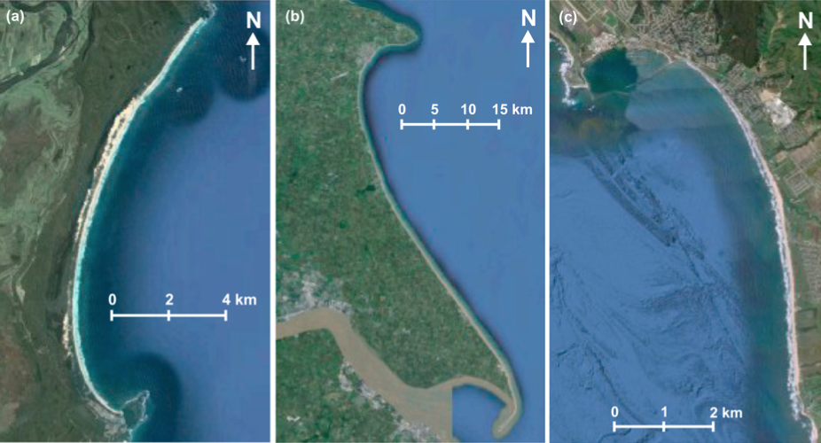

**Figure 2** Examples of crenulated bay shapes at different scales. (a) Hathead Bay, Eastern Australia. (b) Flamborough Head and the Holderness Coastline, East Yorkshire, UK. (c) Half Moon Bay, California, USA.

The curved planform morphology of **embayed beaches** can be observed at various length-scales on coastlines, from a few hundred meters to several kilometers. These log spiral-shaped, crenulate-shaped, hook-shaped, or zeta-shaped bays occur in the lee of headlands or man-made coastal structures where erosion and/or littoral drift is inhibited in the face of a dominant direction of wave incidence. A highly concave portion of shoreline forms on the downdrift side of the headland where the coastline is shadowed from the dominant wave direction and subject to waves that diffract around the headland.

**Embayed beaches** tend toward an equilibrium form under a prevailing wave climate. The planform morphology will adjust until gradients in alongshore sediment flux are minimized (net alongshore sediment flux is constant). Alongshore sediment flux will be negligible on an equilibrium coastline when there are no external sediment inputs. Subsequent changes in planform morphology may occur such as beach rotation, driven by changes in wave climate characteristics that alter alongshore sediment transport.

**Initial settings**

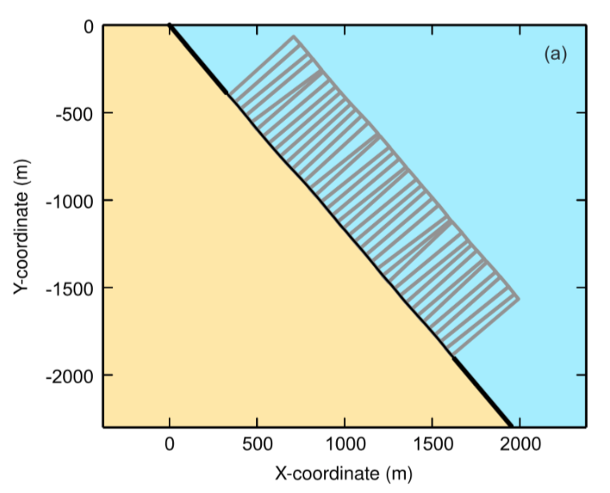

**Figure 3** Coastal cell geometry for a model instance at the beginning of a model run starting with a straight coastline with superimposed low amplitude noise in the coastline position.

.

Go to the folder **COVE** and open theBaySensitivity.ipynb notebook. The COVE simulations that you will be running will study the evolution of embayed beaches proximal to fixed headlands and will be use to explore the influence of a variable wave climate on predicted bay morphology and stability.

Initial model coastlines are straight and 2 km in length with initial node spacing of 50 m.

The bounding ends of the coastline are fixed to represent headlands or fixed structures such as sea walls.

No sediment transport is permitted into the model domain across these boundaries, but sediment is permitted to escape out of the model domain by alongshore transport.

**Wave climates**

We will use for this exercise an idealized wave climate. The offshore wave directions **θ0** are drawn from Gaussian functions defined by mean **θmean** and standard deviation **θstd**. Offshore wave height **H0** and period **T** are also described using a narrow Gaussian function with **Hmean** and standard deviation **Hstd**, and **Tmean** and **Tstd**.

**Running COVE**

The model has been set to run over 20 years to ensure profile equilibrium. Using the notebook you will perform multiple scenarios by changing the wave field between each simulation.

Following theBaySensitivity.ipynb notebook instructions, you will be able to run your first model using the following values for each parameter:

* **θmean** and **θstd**: 25o and 10 o
* **Hmean** and **Hstd**: 1 m and 0.1 m
* **Tmean** and **Tstd**: 6 s and 1 s

To answer the questions regarding the COVE model it is highly recommended to go through the COVE paper available here:

* [Paper on COVE](http://onlinelibrary.wiley.com/doi/10.1002/2015JF003704/abstract)

Q1. Run a series of models with θmean=30o and a variation of spreading angles θstd using successively values of 10o, 25o and 40o. For each of these angles plot the shoreline evolution over the 20 years. What is the effect of increasing the spreading of the wave directions for the embayment at the shadowed end of the bay? What is the reason for that? (Attached if required figures or illustrations to support your explanation in your report).

________________________________________________________________________________________________________________________________________________________________________________________________________________________________________________________________________________________________________________________________________________________________________________________________________________________________________________________________________________________________________________________________________________________________________________________________________________________________________________________________________________________________________________________________________________________________________________________________________________________________________________________________________________________________________________________________________________________________________________________________________________________________________________________________________________________________________________________________________________________________________________________________________________________________________________________________________________________________________________________________________________________________________________________________________________________________________________________________________________________________________________________________________________________________________________________________________________________________________________________________________________________________________________________________________________________________________________________________________________________________________________________________________________________________________________________________________________________________________________________________________________________________________________

Q2. Run a series of models with θstd=25o and a variation of dominant wave directions θmean using successively values of 10o and 40o. For each of these angles plot the shoreline evolution over the 20 years. Using these two new models explain what is the effect of increasing the obliquity of wave approach angles? Again what is the reason for that? (Attached if required figures or illustrations to support your explanation in your report).

____________________________________________________________________________________________________________________________________________________________________________________________________________________________________________________________________________________________________________________________________________________________________________________________________________________________________________________________________________________________________________________________________________________________________________________________________________________________________________________________________________________________________________________________________________________________________________________________________________________________________________________________________________________________________________________________________________________________________________________________________________________________________________________________________________________________________________________________________________________________________________________________________________________________________________________________________________________________________________________________________________________________________________________________________________________________________________________________________________________________________________________________________________________________________________________________________________________________________________________________________________________________________________________________________________________________________________________________________________________________________________________________________________

**Yanchep perched beach and natural breakwater**

In this exercise you will work on a beach 60 km north of Perth (WA) most commonly known as Yanchep lagoon. Many beaches in WA like Yanchep are fronted by shallow reef and here you will investigate the effects of the reef on the morphodynamics.

Natural perched beaches are formed in association with a variety of natural coastal structures. The most common formations associated with **perched beaches include coral reefs** (live or fossilised), **beachrock** and **aeolianite** (dune rock).

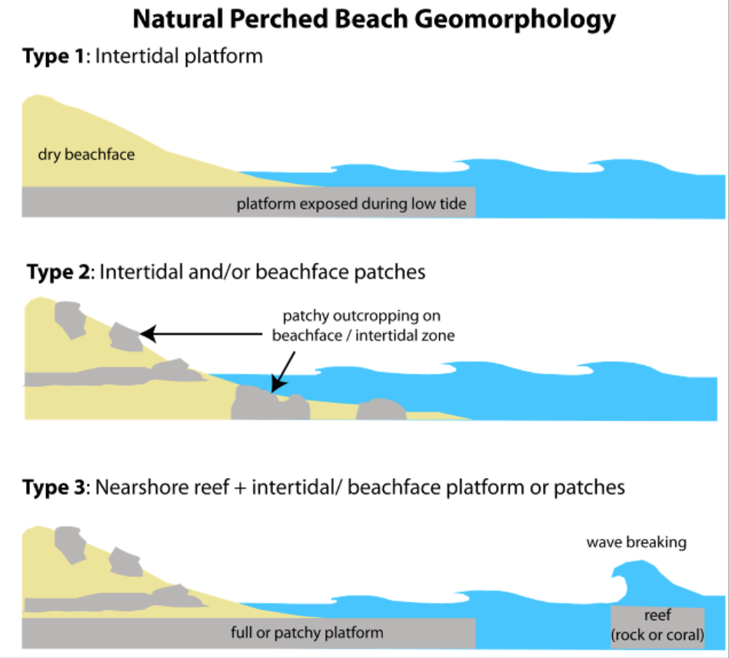

**Figure 4** Classification of natural perched beaches using a geomorphic approach.

The three main geomorphic types of natural perched beaches mentioned in existing literature are:

1. intertidal platform of relatively continuous rock;
2. patchy beachrock in the intertidal zone and/or on the beachface; and
3. a rock or coral reef attenuating wave energy which may be in combination with an intertidal platform and/ or rock patches in the intertidal zone or on the beachface.

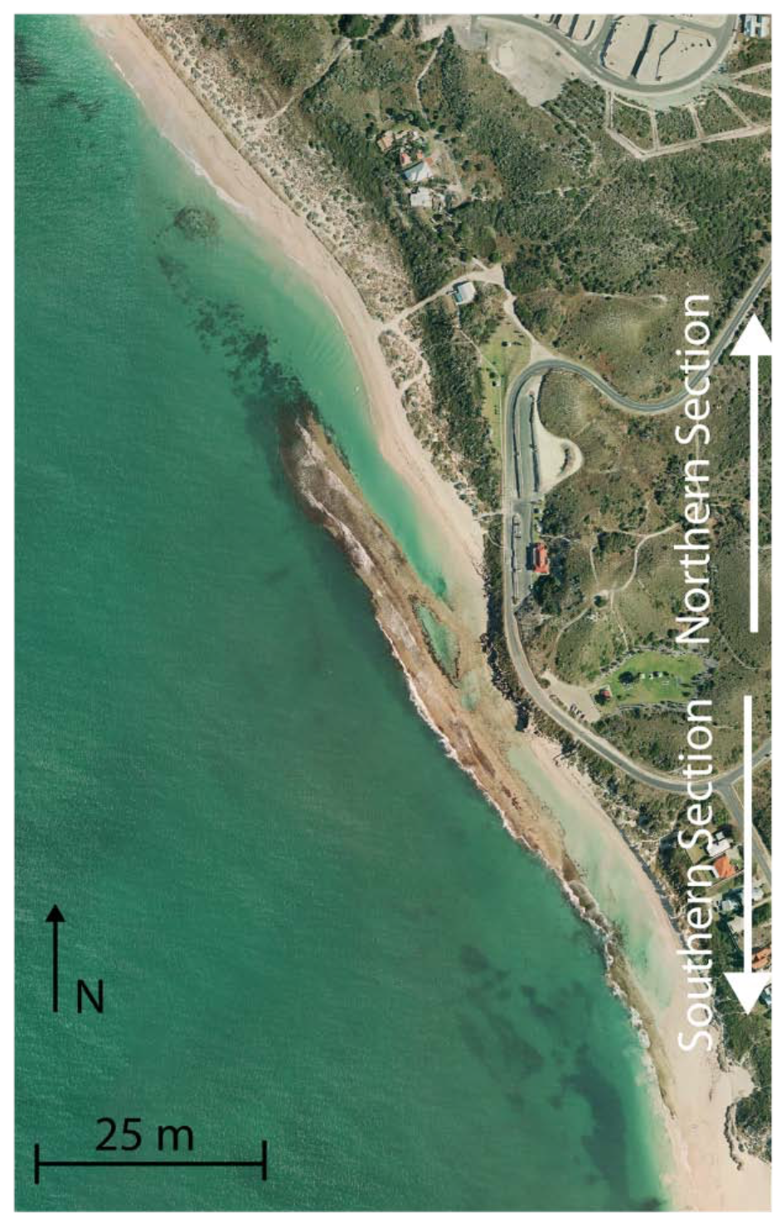Mechanisms through which coastal structures affect beach behaviour operate on a variety of temporal and spatial scales, from micro- to megascale. Here you will focus on changes in the **mesoscale** over several hours over m/km.

**Yanchep Lagoon** is perched on Quaternary Limestone formations. The beach consists of medium sand with d50 of 0.4 mm. Whilst the local coastal structure geometry varies along the 2 km- long beach, most of the beach is Type 4 (**Nearshore reef + platform/ patches**) – fronted by a limestone reef partially closing a lagoon and underlain by limestone.

For this exercise it is highly recommended to read the paper **Gallop et al. (2011)** provided in the **Yanchep** folder. To simulate the effects of the shallow reef on the morphological evolution of the beach during a storm we will use **XBeach** model in 2D and visualise the results with **Paraview**. For those using their own laptop you can download Paraview from the following [link](http://www.paraview.org/download/).

Field data during winter storm event has revealed processes by which the coastal structures affect the beach behaviour. During a winter storm, beach profiles fronted seaward by limestone suffered less erosion but also recovered less. During the summer sea breeze, the beach section fronted seaward by submerged limestone near the lagoon exit suffered more erosion but had less overnight recovery. The coastal structures at Yanchep strongly influence the hydrodynamics, which in turn affects the beach behaviour. 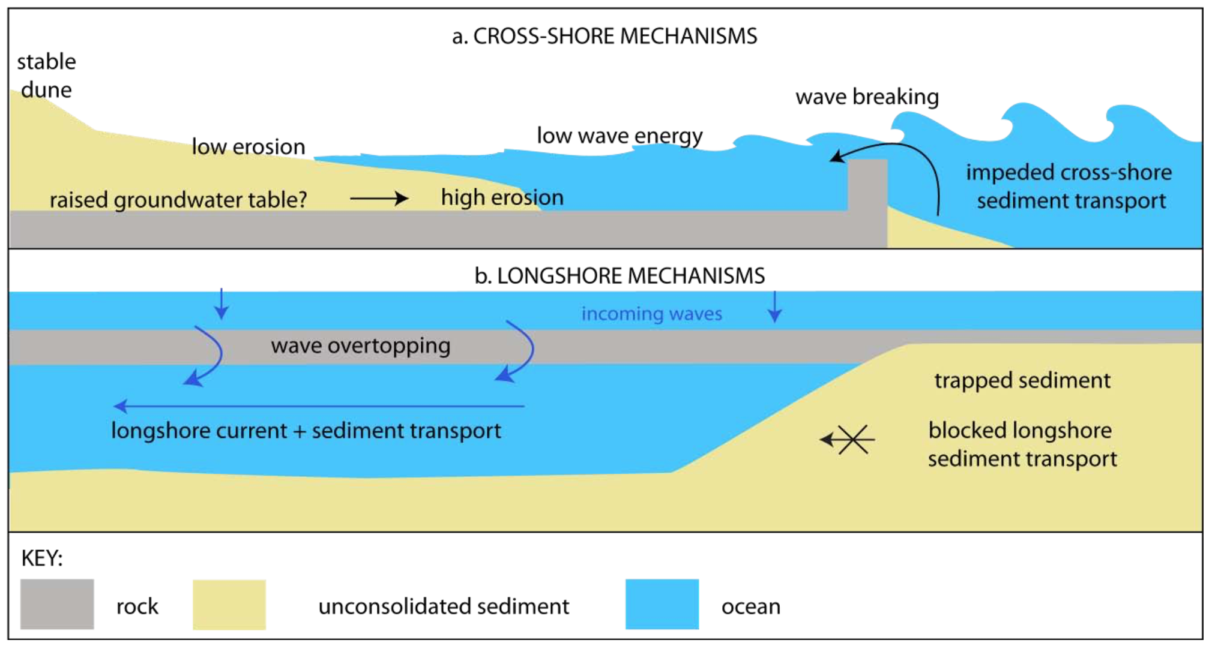

Go to the folder **Yanchep** and open theYanchepLagoon.ipynb notebook. Play the first cells to run the **XBeach** model. The simulation will take about 15 minutes to run. Meanwhile we will use the YanchepVis.ipynb notebook to create the output for **Paraview**. Copy the created folder on your local computer as well as the state file (*paraviewstate.pvsm*). Open the state in Paraview.

Q3. Inspect the bathymetry file and the structure file. What is the depth in the lagoon? Is the reef enclosing the lagoon below or above the model initial water level? What is the wave height at the boundary condition?

________________________________________________________________________________________________________________________________________________________________________________________________________________________________________________________________________________________________________________________________________________________________________________________________________________________________________________________________________________________________________________________________________________________________________________________________________________________________________________________________________________________________________________________________________________________________________________________________________________________________________________________________________________________________________________________________________________________________________________________________________________________________________________________________________________________________________________________________________________________________________________________________________________________________________________________________________________________________________________________________________________________________________________________________________________________________________________________________________________________________________________________________________________________________________________________________________________________________________________________________________________________________________

Q4. When the simulation is finished visualise the wave height (H) and Eulerian velocities (ue and ve) evolution with time. In relation to the evolution of the beach morphology (cumulative sedimentation/erosion) explain what is happening in the lagoon? (Attached some figures to support your explanation in your report).

____________________________________________________________________________________________________________________________________________________________________________________________________________________________________________________________________________________________________________________________________________________________________________________________________________________________________________________________________________________________________________________________________________________________________________________________________________________________________________________________________________________________________________________________________________________________________________________________________________________________________________________________________________________________________________________________________________________________________________________________________________________________________________________________________________________________________________________________________________________________________________________________________________________________________________________________________________________________________________________________________________________________________________________________________________________________________________________________________________________________________________________________________________________________________________________________________________________________________________________________________________________________________________________________________________________________________________________________________________________________________________________________________________

Q5. How is the lagoon affected by the mean water level? Increase or decrease the mean water level condition (‘tide.txt’), run the model again (maybe for a shorter time by reducing keyword: tstop). How are the circulation and sediment transport affected? (Attached some figures to support your explanation in your report).

____________________________________________________________________________________________________________________________________________________________________________________________________________________________________________________________________________________________________________________________________________________________________________________________________________________________________________________________________________________________________________________________________________________________________________________________________________________________________________________________________________________________________________________________________________________________________________________________________________________________________________________________________________________________________________________________________________________________________________________________________________________________________________________________________________________________________________________________________________________________________________________________________________________________________________________________________________________________________________________________________________________________________________________________________________________________________________________________________________________________________________________________________________________________________________________________________________________________________________________________________________________________________________________________________________________________________________________________________________________________________________________________________________

Q6. Reefs are very rough what happens in the model when the friction is increase? To investigate this effect, reduce the Chezy roughness (keyword: C) and increase the value of the bed friction factor (keyword: fw). Rerun the model, what do you observed? (Attached some figures to support your explanation in your report).

______________________________________________________________________________________________________________________________________________________________________________________________________________________________________________________________________________________________________________________________________________________________________________________________________________________________________________________________________________________________________________________________________________________________________________________________________________________________________________________________________________________________________________________________________________________________________________________________________________________________________________________________________________________________________________________________________________________________________________________________________________________________________________________________________________________________________________________________________________________________________________________________________________________________________________________________________________________________________________________________________________________________________________________________________________________________________________________________________________________________________________________________________________________________________________________________________________________________________________________________________________________________________________________________________________________________________________________________________________________________________________________________________________________________________________________________________________________________

Q7. Now you will turn on the wave/current interaction (keyword: wci=1). Rerun the model and compare the output with the model you ran previously. How much effect do you see on the morphology? (Attached some figures to support your explanation in your report).

______________________________________________________________________________________________________________________________________________________________________________________________________________________________________________________________________________________________________________________________________________________________________________________________________________________________________________________________________________________________________________________________________________________________________________________________________________________________________________________________________________________________________________________________________________________________________________________________________________________________________________________________________________________________________________________________________________________________________________________________________________________________________________________________________________________________________________________________________________________________________________________________________________________________________________________________________________________________________________________________________________________________________________________________________________________________________________________________________________________________________________________________________________________________________________________________________________________________________________________________________________________________________________________________________________________________________________________________________________________________________________________________________________________________________________________________________________________________